* Learn netmask calculation table
* Two VMs: client and server
* Deny incoming ICMP traffic with IPTables to server
* Allow incoming SSH connections to client from Server ONLY (all other – deny)

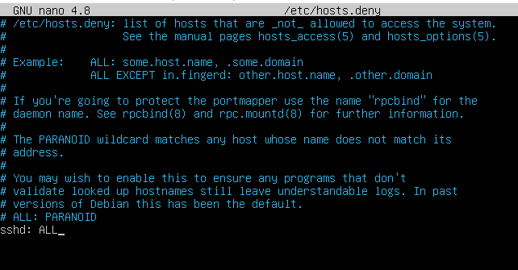

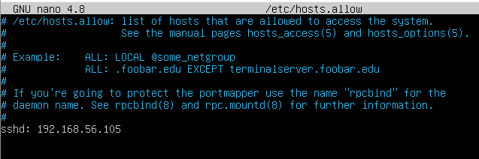

* Send screenshots: ping \ ssh outputs

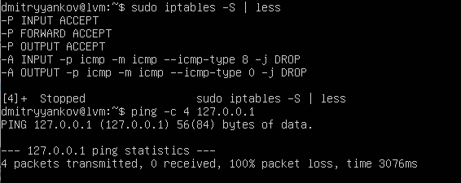

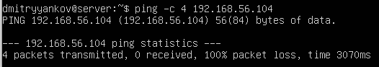

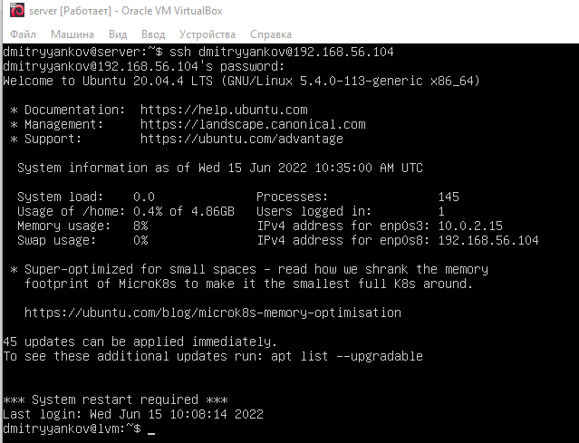

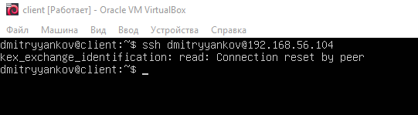

* Send screenshots: iptables configuration

